What is devops?

Devops is an evolution from the agile model of software development.

Easy to address gaps between both client and development team as well as developers and operations team.

Phases

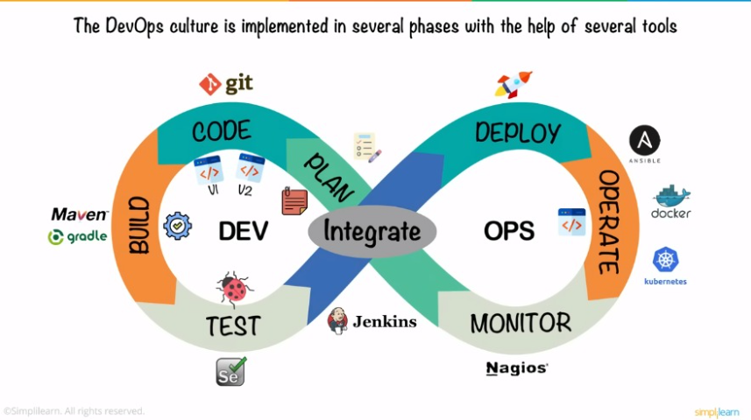

Continuos integration and continuos deployment

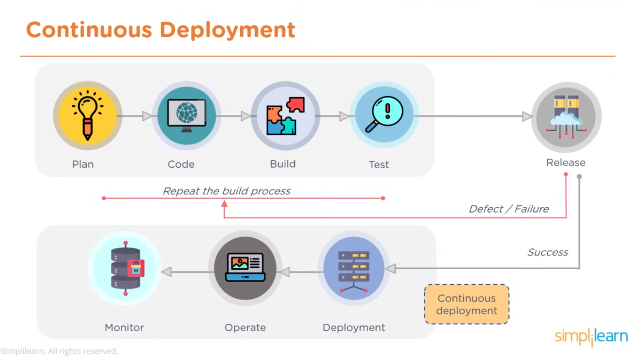

Devops tools

